**Courier Management:**

**Abstract**:

Courier Management is a PHP, MySQL based project, demonstrating the functionalities required to run a Courier Service. With the advent of internet applying for Courier Service and Doing Courier has become a hassle free task. The User can book a Courier and canview the status for the courier . Courier Management enables a branch manager to view all the couriers and manage the employees under him. An manager can update the status of the courier and mark the courier as delivered and specify the employee who delivered the courier. Courier Management project is made up of 2 modules namely, Branch and User.

**Introduction:**

With the advent of internet applying for Booking for Courier has become a hassle free task. Courier Management is an application developed using html, CSS, Javascript, Php and Mysql technologies which connects User and Courier Service provider where Users register themselves and book for Courier Service using the system. And the branch Manager can view and make deliveries for the couriers,only the registered User can book for Courier and view status of booked courier. The branch manager can add new staff members or delete them. The status of the Courier can be changed by the branch manager and also specifying the staff member who delivered it.

**Modules:**

1. **User Module**:

* New User can register into the system.
* Apply for the Courier Service.
* View the current status His couriers .

1. **Branch Module:**

* New Branch can register into the system.
* Add new Staff members.
* Manage Staff Members.
* View All the Couriers.
* Deliver the Courier.

**System design:**

Courier

Branch

User

Staff

**ER diagram:**

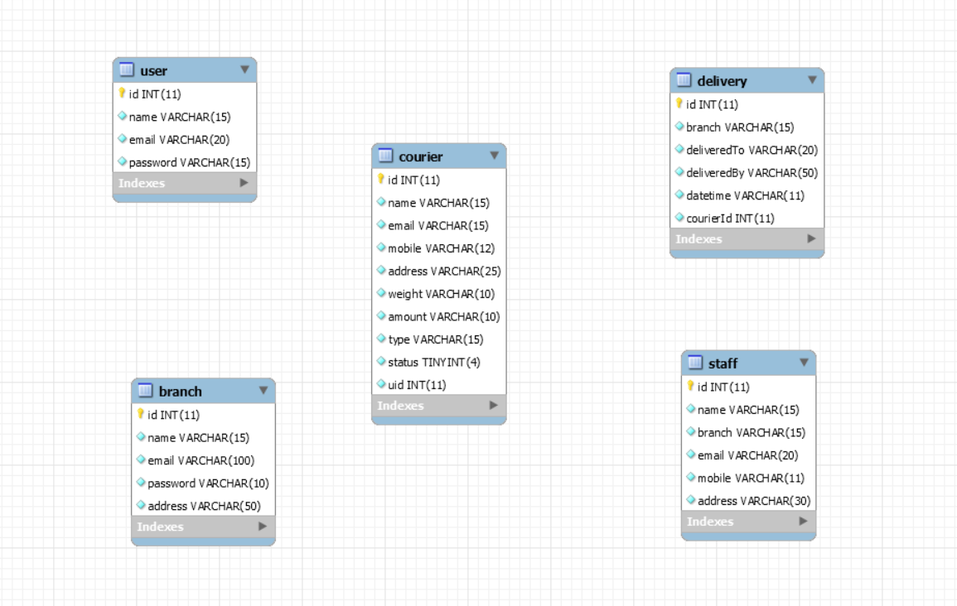

**Project Screenshots**:

Take the screenshots as per walkthrough video or based on your understanding of project.